Multiple choice section

|  |  |  |  |  |  |  |  |  |
| --- | --- | --- | --- | --- | --- | --- | --- | --- |
| Question | 1 | 2 | 3 | 4 | 5 | 6 | 7 | 8 |
| Answer | B | D | D | A | C | D | B | A |

Question 1 [6.1]

B



Question 2 [6.1]

D

18' =

= 0.3

So = 25.3

35.28 + 25.3 = 60.58°

Question 3 [6.2]

D



Different methods of solution are also possible.

Question 4 [6.2]

A

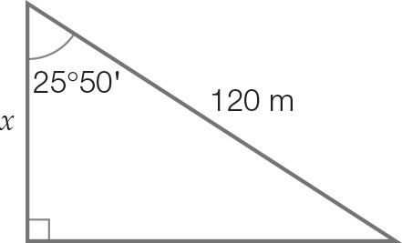

cos(25°50′) = 

x = 120 × cos(25°50′)

x = 108.01 m (2 d.p.)

Question 5 [6.3]

C



Question 6 [6.4]

D

tan(24 = 

x = 22 × tan(24

x = 9.80 (2 d.p)

Question 7 [6.5]

B

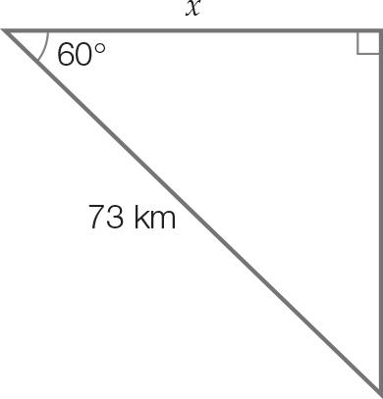

cos(60 = 

x = 73 × cos(60

x = 36.5 km

Question 8 [6.5]

A

  


N30E

Multiple-choice total marks: 8

Short answer section

Question 9 2 marks [6.2]

|  |  |
| --- | --- |
|  |  |

Question 10 2 marks [6.3]

|  |  |
| --- | --- |
| Kite 1: | Kite 2: |

Question 11 3 marks [6.4]

After 2 seconds, the dog has run 16 m. The angle between the tree and line of sight of top of the tree to the dog:



Angle of depression:



Question 12 3 marks [6.4]

Height from ground level to eye level:  
583 cm + 15 cm = 598 cm

Let θ be the angle of elevation.





Question 13 4 marks [6.6]

|  |  |
| --- | --- |
| (a) Let θ be the angle line AB makes with the horizontal.  True bearing: 90 – 54.5 = 035.5T | (b) Let x be the length BC. Using Pythagoras’ theorem: |

Short answer total marks: 14

Extended response section

Question 14 6 marks [6.6]

Let x be the length of the first cable.



Let y be the length of the second cable.



Total length:

1058.83 + 1392.46 = 2451.29 cm

Round to the nearest cm: 2451 cm

Question 15 5 marks [6.5]

(a) 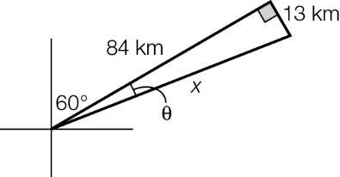  
  
Total: 84 + 13 + 85 = 182 km

(b)   
  
True bearing is 60 + 8.80 = 068.80T.

Extended answer total marks: 11

TOTAL test marks: 33